|  |  |  |
| --- | --- | --- |
|  | User Experience Guide | |
| 8/23/2013 | Graduate Capstone |  |

Table of Contents

1 Introduction 3

1.1 Intended Audience 3

1.1 References 3

1.2 Revision History 3

2 Logo 4

2.1 The Logo 4

2.1.1 Black and White 4

2.1.2 Color 4

2.1 Elements of Logo 4

2.1.1 Barcode 4

2.1.2 Arrows 4

2.9 Prototypes 4

3 Fonts 5

3.1 Typefaces 5

3.1.1 Lucidia Console (Sans Serif) 5

3.1.2 Lucidia Bright (Serif) 5

4 Colors 6

4.1 Purples 6

4.2 Greens 7

4.3 Neutrals 8

5 Design Elements 9

# 1 Introduction

The purpose of this document is to describe the user interface standards to follow in the development of the front-end aspects of the applications. By doing this, the goal is that there will be a sense of consistency between all the applications.

## 1.1 Intended Audience

This document is intended for any persons who wish to utilize the Phone Application and gain a better understanding of how the screens work. This document is written for people with any degree of familiarity with the application.

## 1.1 References

* <http://www.globway.eu/files/100511%203API%20User%20Experience%20Guideline.pdf>
* <http://www.ixda.org/sites/default/files/UX_Kit_Aug09.pdf>
* <http://creativetest2008.files.wordpress.com/2008/05/blogs-v121doc.pdf>
* <http://www.mass.gov/eohhs/docs/eohhs/eohhs-user-experience-and-style-guide-v3.pdf>
* <http://www.wsdot.wa.gov/eesc/bridge/software/files/user%20interface%20specification.pdf>
* <http://web.fe.up.pt/~jlopes/lib/exe/fetch.php/teach/lbaw/lectures/ibm_uia.pdf>

## 1.2 Revision History

Managing the change history of this document will occur in this table.

|  |  |  |  |
| --- | --- | --- | --- |
| Name | Date | Reason For Change | Version |
| Andy Bottom | 07/29/2013 | Added the initial categories for the document. Also added references. | 0.1 |

# 2 Logo

@TODO: Add description

## 2.1 The Logo

This is the logo that will be used on for the phone application.

### 2.1.1 Black and White

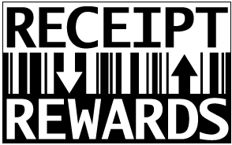

### 2.1.2 Color

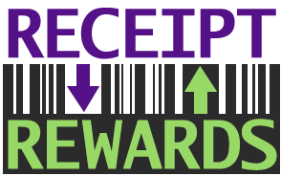

## 2.1 Elements of Logo

The following section contains the design elements involved in the logo.

### 2.1.1 Barcode

The barcode is very symbolic of the receipts. The barcode can also be an element reused throughout the app

### 2.1.2 Arrows

I wanted to uses errors to represent the transactional relation between the Receipt and the Rewards. The arrows are also elements used throughout the app.

## 2.2 Prototypes

The following section contains the prototypes of the logos.

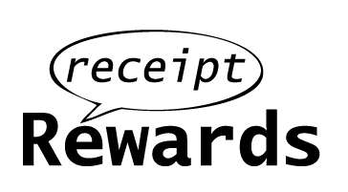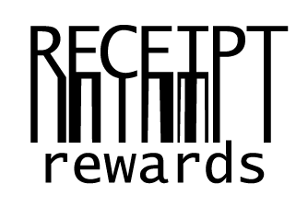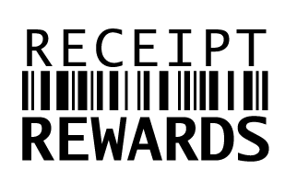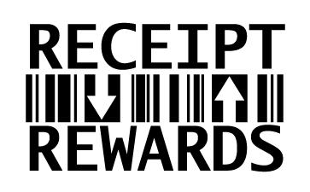



# 3 Fonts

The following section contains all the information about the fonts used in the project.

## 3.1 Typefaces

The Typefaces used throughout the applications and the documentation is very important. The text needs to be consistent throughout the app. Below is a list of both Serif and San Serif font faces. Typically, for Headings, the Sans Serif will be used. Otherwise for body text, the serif font face will work best.

### 3.1.1 Lucidia Console (Sans Serif)

We decided to go with the Lucidia Sans because the typeface on receipts is Lucidia Console. This is the typeface used in the Receipt Rewards Logo.

### 3.1.2 Lucidia Bright (Serif)

For a serif font, we will be going with the sister font Lucidia Bright for the serif option.

# 4 Colors

This section contains all the colors used in the project. The colors are a schema. The first colors in each row are the main ones. There others are simply a shade to help show of the other colors and have a contrast.

## 4.1 Purples

The color purple was chosen because it has a royal connotation to it.

|  |  |  |  |
| --- | --- | --- | --- |
| Color | RGB | HSB | Hexadecimal |
|  | R: 85 G: 17 B: 136 | H: 273 S: 87 B: 53 | #551188 |
|  | R: 99 G: 63 B: 127 | H: 272 S: 50 B: 49 | #633F7F |
|  | R: 189 G: 121 B: 242 | H: 272 S: 49 B: 94 | #BD79F2 |

## 4.2 Greens

The color green was chose to represent the rewards, due to the money connotation green has.

|  |  |  |  |
| --- | --- | --- | --- |
| Color | RGB | HSB | Hexadecimal |
|  | R: 152 G: 216 B: 102 | H: 93 S: 52 B: 84 | #98D866 |
|  | R: 22 G: 51 B: 0 | H: 93 S: 100 B: 20 | #163300 |
|  | R: 67 G: 76 B: 61 | H: 94 S: 19 B: 29 | #434C3D |
|  | R: 44 G: 102 B: 0 | H: 93 S: 100 B: 40 | #2C6600 |
|  | R: 73 G: 168 B: 0 | H: 93 S: 100 B: 65 | #49A800 |

## 4.3 Neutrals

The few neutral colors help support and enhance the colors that are used.

|  |  |  |  |
| --- | --- | --- | --- |
| Color | RGB | HSB | Hexadecimal |
|  | R: 43 G: 43 B: 43 | H: 93 S: 0 B: 16 | #2B2B2B |
|  | R: 218 G: 221 B: 215 | H: 88 S: 22 B: 86 | #DADDD7 |
|  | R: 17 G: 16 B: 17 | H: 299 S: 5 B: 6 | #111011 |

# 5 Design Elements

This contains elements that are used throughout the entire project. The elements are reused throughout the application to provide unity.

@TODO: Create GUI Elements section about the elements of the Windows Phone and the Android Application.

## 5.1 Windows Phone

The Windows Phone OS has a very distinctive user experience.. To keep up to date and utilize these elements, a list below will describe in more detail what to look for and use in the front-end of the Windows Phone Application.

### 5.1.1 Panorama View

The first main UX element that will be utilized is the Panorama View. The panorama view is unique as it can be considered a very long page of which the phone can slide to see more content. The pages work by adding Panorama Items to the Panorama view. These items are the actually things that display to the user. The function of the user is in contain and hold the sever Panorama Items to create a very distinctive view.



## 6 Prototypes and Wireframes

A wireframe and mock of the interface of the phone application during the initial design phase of the application. By doing this, it could be planned how the user would interface with the system and utilize the functionality. This allowed use cases to by create specifically aimed at the phone user.

## 6.1 Phone Application

### 6.1.1 Dashboard / Main Menu

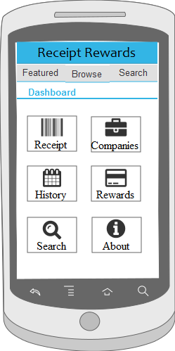

This is the dashboard or main menu page. From here, the use will be able to get to all the functionality of the system.

### 6.1.2 Register Page

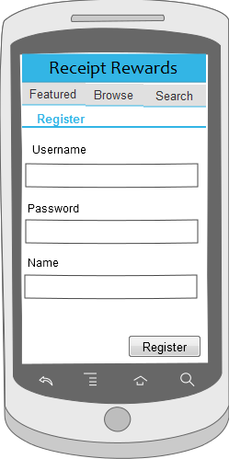

This is a register page so that an anonymous user can register and create a user account for them.

### 6.1.3 Login Page

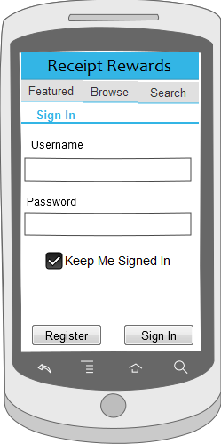

The login page provides the functionality for the user to be able to login to their user account.

### 6.1.4 Login Welcome

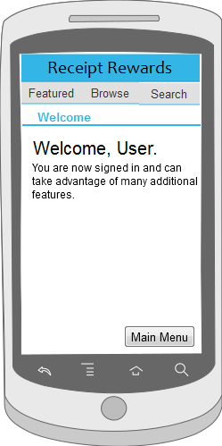

This is the welcome page for the user.

### 6.1.5 Search

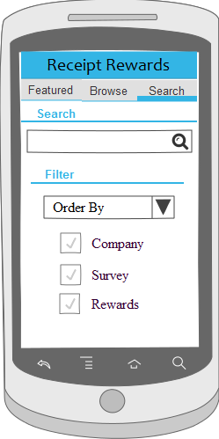

The search gives the user a search box and advanced options to be able to search for companies and surveys.

Upon searching, it will display the search result page.

### 6.1.6 Search Results

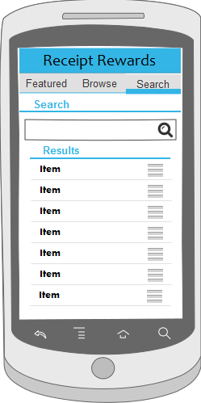

This is the search results page. The result will be of companies and surveys. They can select an item and go to either the Company Page or the Survey Page.

### 6.1.7 Company List

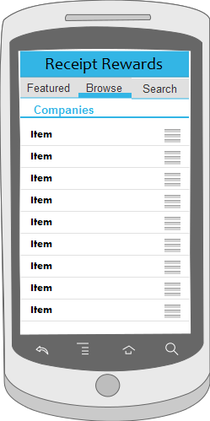

The company list page is used to display a list of all the companies to the user.

From here, a user can select a company to view which will display the company page to the user.

### 6.1.8 Company Page

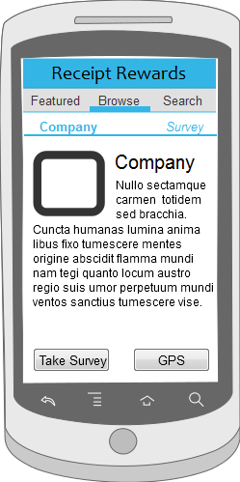

The company page is the page which displays all the information about a company to the user.

From this page, a user can also navigate the survey corresponding to that company.

### 6.1.9 Featured Company Page

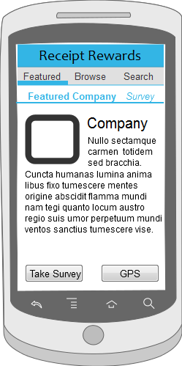

The featured company page is a place in the application where a company can pay to be listed in a special section. Kind of like a advertising spot for companies.

### 6.1.10 Survey Page

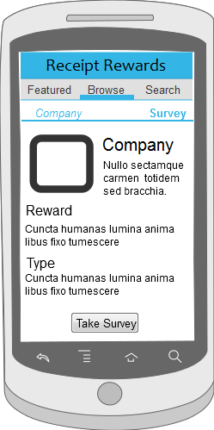

Survey page provides information regarding the survey and what the reward will be. From here, they can click take survey to move on to filling out the survey.

### 6.1.11 Survey

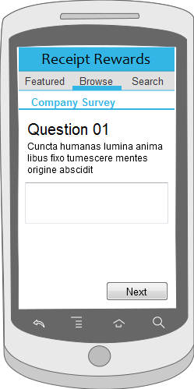

This is the page where they are actually taking the survey and the first question is displayed. They go through these screens until they finish.

### 6.1.12 Survey Complete

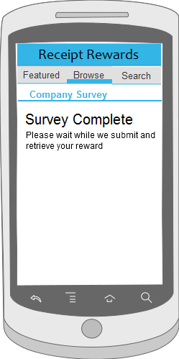

Once they finish taking the survey the will see the complete page. It is also on this page where they will receive information about how to get their reward.